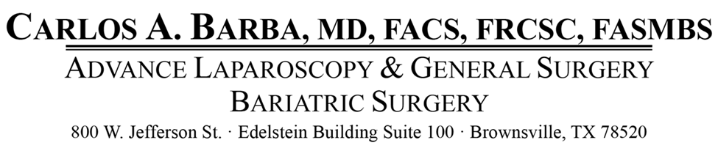
The following information is provided to help you better understand the cash price package for Carlos A. Barba M.D.
______ Laparoscopic Sleeve Gastrectomy $2500.00

______ Laparoscopic Gastric Bypass Surgery $3000.00

______ Laparoscopic Revision $3000.00

______ Sleeve Gastrectomy as a secondary procedure $1500.00

______ Gastric Bypass as a secondary procedure $2000.00

This amount should be paid in full before registering for your surgery.

Print Name: ______________________ DOB: _______________

Patient’s Signature: ________________________________________ Date: ________________

Witness Signature: _____________________________________ Date: ______________

